Project Proposal NutriTrack Hub

1. Overview

NutriTrack Hub is a web application designed to help users monitor their daily nutrient intake and maintain a balanced diet. Many people struggle to meet their daily nutritional goals due to busy lifestyles, lack of knowledge, or inconsistent meal tracking. My motivation is to provide a simple, platform where users can log meals, track calories, macros, micronutrients, and receive personalized recommendations.

1. Target Audience

This application is targeted at anyone but specifically useful for:

* Health-conscious adults, athletes, or fitness enthusiasts.
* People who are trying to manage weight, diet-related health conditions, or general wellness.
* Anyone interested in tracking daily food intake and nutrient balance.

1. Major Functions

* **Log a Meal:** Users can log meals by entering food items, portion sizes, or searching the database. The application calculates calories and nutrients automatically.
* **View Daily Nutrient Summary:** Users can see a summary of their daily intake, including calories, protein, carbs, fats, vitamins, and minerals.
* **Set Nutrient Goals:** Users can define daily calorie and macronutrient targets. The application tracks progress and shows whether goals are met.
* **Track Nutrient Trends:** Users can view graphs and charts showing their nutrient intake trends over days, weeks, or months.
* **Get Food Recommendations:** The application suggests foods or recipes to help users meet their nutrient goals.
* **Edit or Delete Meals:** Users can modify or remove logged meals if they make a mistake or change their plan.
* **Export Reports:** Users can export their meal logs and nutrient summaries as PDF or CSV files.
* **Manage Profile and Settings:** Users can update personal details, dietary preferences, or application settings.

1. Wireframes
2. Mobile View:

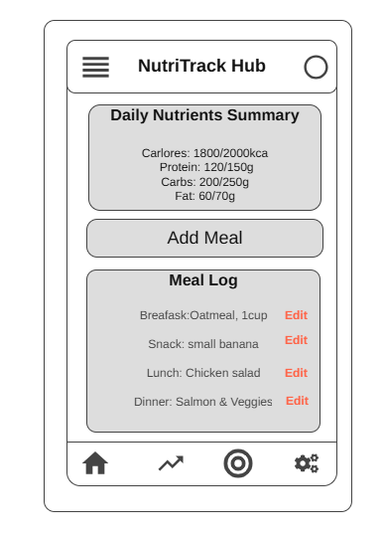

1. Desktop View:

1. External Data and Data storage
2. **External Data**

* **USDA FoodData Central API:** To fetch detailed nutrient information for food items, including calories, macronutrients, and micronutrients.
* **Edamam Food Database API:** As a supplement to USDA data, to provide additional food items, recipes, and nutrient breakdowns.

1. **Data Storage:**

* **Local Storage:** To store users’ meal logs, daily nutrient summaries, goals, and personal preferences.

1. Module List

* **UI Module:** Handles all user interface elements, including rendering meal logs, displaying daily nutrient summaries, charts, and managing navigation between views.
* **Data Management Module:** Handles data storage and retrieval using Local Storage, including meals, nutrient totals, goals, and personal preferences.
* **Event Handling Module:** Manages user interactions and events, such as adding/editing/deleting meals, setting goals, and updating the dashboard.
* **API Module:** Fetches nutrient information from external APIs (e.g., USDA FoodData Central or Edamam) when users search for food items.
* **Export Module:** Prepares and exports reports of daily or weekly nutrient intake as PDF or CSV files.
* **Notification Module:** Manages alerts and reminders for daily meal logging or nutrient goals.
* **Settings/Profile Module:** Handles user preferences, dietary restrictions, and profile management.
* **Visualization Module:** Generates charts and graphs for nutrient intake trends over days or weeks.

1. Graphic Identity

* **Color Scheme:** A clean and healthy look with a **white background** (#FFFFFF) and vibrant accent colors **green** (#27AE60), **orange** (#F39C12), and **teal** (#1ABC9C) to highlight key data and interactive elements.
* **Typography:** A combination of a **bold sans-serif font** for headings (e.g., **Poppins Bold)** and a **readable sans-serif or serif font** for body text (e.g., **Roboto Regular**) to ensure clarity and balance readability with visual appeal.
* **Application icon:** A stylized nutrition chart representing daily nutrient tracking, progress, and healthy eating goals.

1. Timeline

**Week Deliverables**

**5** Wireframes completed, set up project repository, initial HTML/CSS structure

**6** Build authentication and meal logging modules, connect API for nutrient data

**7** Implement dashboard, recommendations, export functionality, styling, and testing

1. Project Planning

Trello Board: <https://trello.com/invite/b/68ea897c250802ebb73c73a2/ATTIebcf9b98d38be5bc71ca6cfdc33ec2a3D8A9B787/nutritrack-app-project-plan>

1. Challenges
2. Integrating a third-party food database API reliably.
3. Designing an intuitive dashboard for both mobile and desktop users.